Program Information | [Lesson Title]  Real World Application of Area, Volume, and Surface Area of Two and Three Dimensional Shapes |  |  |  |  | TEACHER NAME  Andrea Karpiak |  |  |  |  | PROGRAM NAME  Mansfield City Schools – Adult & Community Ed
Program Information | [Unit Title]  Real World Application to Area, Volume, and Surface Area |  |  |  |  | NRS EFL(s)  2 – 4 |  |  |  |  | TIME FRAME  Surface Area Activity of Prisms:  90 minutes  Volume and Surface Area of Cylinder Activity:  90 minutes
Instruction | ABE/ASE Standards – Mathematics
Instruction | Numbers (N) |  |  | Algebra (A) |  |  | Geometry (G) |  |  |  | Data (D)
Instruction | Numbers and Operation |  | A.2.2  A.2.10  A.3.9  A.4.4  A.4.6 | Operations and Algebraic Thinking |  |  | Geometric Shapes and Figures |  |  | G.3.5 | Measurement and Data
Instruction | The Number System |  |  | Expressions and Equations |  |  | Congruence |  |  |  | Statistics and Probability
Instruction | Ratios and Proportional Relationships |  |  | Functions |  |  | Similarity, Right Triangles. And Trigonometry |  |  |  | Benchmarks identified in RED are priority benchmarks. To view a complete list of priority benchmarks and related Ohio Aspire lesson plans, please see the Curriculum Alignments located on the Teacher Resource Center.
Instruction | Number and Quantity |  |  |  |  |  | Geometric Measurement and Dimensions |  |  | G.4.4
Instruction |  |  |  |  |  |  | Modeling with Geometry
Instruction | Mathematical Practices (MP)
Instruction |  | Make sense of problems and persevere in solving them. (MP.1) |  |  |  |  |  | Use appropriate tools strategically. (MP.5)
Instruction |  | Reason abstractly and quantitatively. (MP.2) |  |  |  |  |  | Attend to precision. (MP.6)
Instruction |  | Construct viable arguments and critique the reasoning of others. (MP.3) |  |  |  |  |  | Look for and make use of structure. (MP.7)
Instruction |  | Model with mathematics. (MP.4) |  |  |  |  |  | Look for and express regularity in repeated reasoning. (MP.8)
Instruction | LEARNER OUTCOME(S)  - Students will be able to solve real-world mathematical problems of two and three-dimensional objects composed of triangles, quadrilaterals, polygons, cubes, and right prisms. |  |  |  |  | ASSESSMENT TOOLS/METHODS  - Monitor the hands on activities and make sure the students are using the rulers and formulas correctly for calculating surface area of the boxes.  - Also, listen to your students’ conversations on the Volume of a Cylinder Activity to see if students are using vocabulary as to why one of the cylinders holds more of the puff popcorn than the other.  - Students will complete worksheet(s) on surface area and volume of prisms, cones, pyramids, and spheres.
Instruction | LEARNER PRIOR KNOWLEDGE  - Students should have already completed the lesson Finding Perimeter and Area of Polygons and be able to apply formulas for area of triangles, special quadrilaterals, and polygons.  - Students should be able to read the centimeter side of a ruler and round to the nearest half of a centimeter.
Instruction | INSTRUCTIONAL ACTIVITIES  You should have completed G.3.5 Finding Perimeter and Area of Polygons Lesson prior to doing this lesson plan with you students.  Surface Area Activity of Prisms:  - Pass out Mathematics Formula Sheet & Explanation  - Encourage your students to keep this reference and write down their own notes on it how they will find perimeter and area that is more user friendly for them.  - In order to do surface area, students need to be able to find area of basic shapes (Squares, Rectangles, Triangles, and Circles). Give each student a box.  - Explain to your students that they will be finding the individual areas of each of the sides of their box by measuring the lengths and widths and multiply them together.  - Next, they will add all of their individual areas up (front, back, side, side, top, and bottom of the box) to calculate the total surface area. Remember this will be squared centimeters.  - Next, have the students cut the box to open up its net. Have the students measure each of the shapes or sides of the box and calculate the total surface area as shown in the picture below.  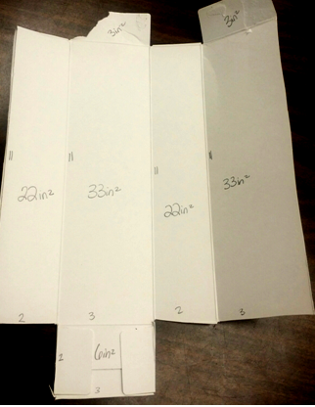  - Explain to your students that they can look at rectangular prisms, right prisms, and pyramids as a net when they are calculating Surface which can be easier than applying the complex formulas given on their formula sheet. However, for cylinders, cones, and spheres the volume formulas can be used.  Have students watch Drawing Nets and Using Nets to Calculate Surface Area to see how Surface Area is calculated with other three dimensional shapes by looking at their nets.  - Your students can practice finding surface area on various shapes. You can choose the worksheet(s) that best fits for your students. Save the surface area of a Cylinder after you complete the next activity below, labeled, Volume and Surface of Cylinder Activity  Easy:  Surface Area – Prism 1  Surface Area – Prism 2  Medium:  Surface Area – Prism 3  Surface Area – Prism 4  Hard:  Surface Area – Prism 5  Surface Area – Mixed Shapes  Advanced:  Surface Area – Compound Shapes 1  Surface Area – Compound Shapes 2  Volume and Surface of Cylinder Activity (lesson adapted from Popcorn Cylinders Anyone?):  - Divide your students into small groups of 2-4 students. Have each group tape together a piece of construction/printer paper in a hamburger fold and a hot dog fold as pictured below. Have your students predict if the volume of these will be the same or if one will be bigger than the other.  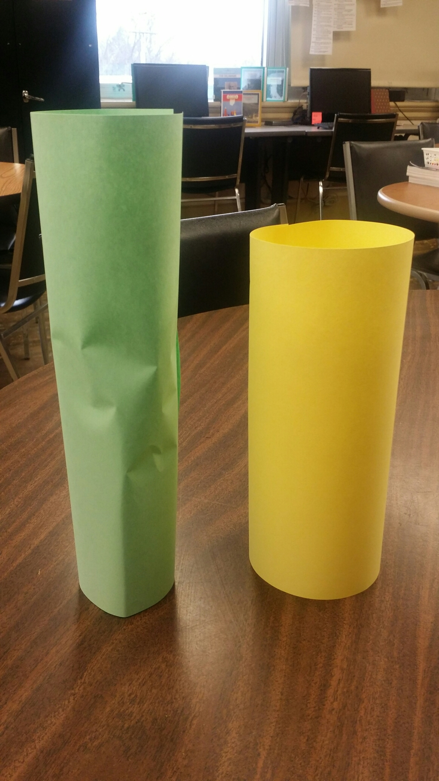  - Students will fill up one of the cylinders to the top with the puff popcorn. Then they will use the same popcorn from one of the cylinders and then put it in the other cylinder to determine if it holds the same, less, or more than the first cylinder.  - Once each group is finished, discuss their findings. They should find that more popcorn will fit in the shorter (yellow cylinder) like in the above picture because the diameter of is larger. Therefore the larger the diameter, the bigger the volume will be. Remind students that Volume is in Cubic Units.  - Lastly have students apply their formula sheet and find the surface area and volume of their cylinders. Use Learn to Find the Volume & Surface Area of a Cylinder as a teaching tool to use before or after students find the Volume and Surface Area of their Cylinders.  - Your students can practice finding volume of Prisms, Pyramids, Cones, Cylinders, and Spheres. You can choose the worksheet(s) that best fits for your students.  Easy:  Volume – Mixed Shapes 1  Volume – Mixed Shapes 2  Medium:  Volume – Mixed Shapes 3  Volume – Mixed Shapes 4  Hard:  Volume – Mixed Shapes 5  Volume – Mixed Shapes 6  Advanced:  Volume – Compound Shapes 1  Volume – Compound Shapes 2 |  |  |  |  |  |  |  | RESOURCES  Student copies of Mathematics Formula Sheet & Explanation  Mathematics Formula Sheet & Explanation [PDF file]. (n.d.). Retrieved from http://www.gedtestingservice.com/uploads/files/0756c16704434ff71e43c8117a5fa738.pdf  Collection of different size food/supply boxes (i.e. cereal, cracker, fruit snacks, etc.) for student use. Each student should have 2 boxes.  Centimeter rulers for student use  Calculators for student use  Computer with Internet access  Projector, ability to project  Speakers  SmithMathAcademy. (2014, March 25). Drawing Nets and using Nets to Calculate Surface Area. Retrieved from https://www.youtube.com/watch?v=Kk7lpQMOuaM  Student copies of leveled worksheets:  Surface Area - Prism 1 [PDF file]. (n.d.). Retrieved from http://www.mathworksheets4kids.com/surface-area/prism-level1-easy1.pdf  Surface Area - Prism 2 [PDF file]. (n.d.). Retrieved from http://www.mathworksheets4kids.com/surface-area/prism-level2-easy2.pdf  Surface Area - Prism 3 [PDF file]. (n.d.). Retrieved from http://www.mathworksheets4kids.com/surface-area/prism-level2-medium1.pdf  Surface Area - Prism 4 [PDF file]. (n.d.). Retrieved from http://www.mathworksheets4kids.com/surface-area/prism-level2-medium2.pdf  Surface Area - Prism 5 [PDF file]. (n.d.). Retrieved from http://www.mathworksheets4kids.com/surface-area/prism-level2-hard1.pdf  Surface Area - Mixed Shapes [PDF file]. (n.d.). Retrieved from http://www.mathworksheets4kids.com/surface-area/mixed-shapes-hard2.pdf  Surface Area - Compound Shapes 1 [PDF file]. (n.d.). Retrieved from http://www.mathworksheets4kids.com/surface-area/compound-shapes1.pdf  Surface Area - Compound Shapes 2 [PDF file]. (n.d.). Retrieved from http://www.mathworksheets4kids.com/surface-area/compound-shapes2.pdf  Popcorn Cylinders Anyone? [PDF file]. (n.d.). Retrieved from https://illuminations.nctm.org/uploadedFiles/Content/Lessons/Resources/6-8/Popcorn-AS-Cylinders.pdf  2 pieces of printer/construction paper per group  Tape for student use  ½ bag of puff popcorn per group.  MashUp Math, H. (2015, September 14). Learn to find the Volume & Surface Area of a Cylinder | Common Core Geometry. Retrieved from https://www.youtube.com/watch?v=Bb_XJ7UPDlM  Student copies of leveled worksheets:  Volume - Mixed Shapes 1 [PDF file]. (n.d.). Retrieved from http://www.mathworksheets4kids.com/volume/mixed-shapes-easy1.pdf  Volume - Mixed Shapes 2 [PDF file]. (n.d.). Retrieved from http://www.mathworksheets4kids.com/volume/mixed-shapes-easy2.pdf  Volume - Mixed Shapes 3 [PDF file]. (n.d.). Retrieved from http://www.mathworksheets4kids.com/volume/mixed-shapes-medium1.pdf  Volume - Mixed Shapes 4 [PDF file]. (n.d.). Retrieved from http://www.mathworksheets4kids.com/volume/mixed-shapes-medium2.pdf  Volume - Mixed Shapes 5 [PDF file]. (n.d.). Retrieved from http://www.mathworksheets4kids.com/volume/mixed-shapes-hard1.pdf  Volume - Mixed Shapes 6 [PDF file]. (n.d.). Retrieved from Volume - Mixed Shapes 5 [PDF file]. (n.d.). Retrieved from http://www.mathworksheets4kids.com/volume/mixed-shapes-hard1.pdf  Volume - Compound Shapes 1 [PDF file]. (n.d.). Retrieved from http://www.mathworksheets4kids.com/volume/compound-shapes-easy1.pdf  Volume - Compound Shapes 2 [PDF file]. (n.d.). Retrieved from http://www.mathworksheets4kids.com/volume/compound-shapes-easy2.pdf
DIFFERENTIATION

- The students are completing several hands on activities that allows them to learn through structured discovery.
- Students will recognize that surface area to three dimensional shapes is simply using their basic area formulas and adding all of the composite shapes together to total the surface area. The students are also visually seeing from the volume of a cylinder activity that the circumference of the ends is what determines which cylinder will hold the most puff popcorn.
- The videos help to guide the students with surface area and volume in order to get visual representations of how the formulas are applied.
- There are several worksheets available for surface area and volume so that they can be differentiated among your various learners.
Reflection | TEACHER REFLECTION/LESSON EVALUATION
Reflection | Additional Information

